Bison

**Table of Contents**

1. High Level Architecture 3

2. Technology Stack 4

3. Document Workflow 4

4. Server Requirements 5

5. Deployment Artifacts 5

6. Installation Steps 6

# High Level Architecture

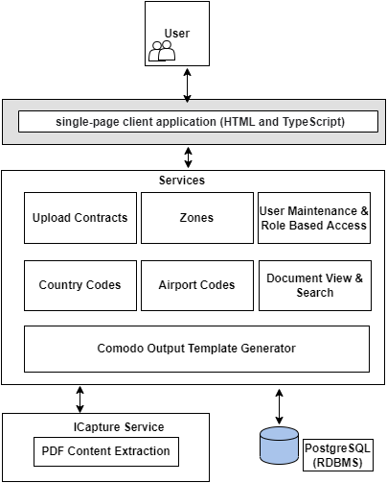

# Technology Stack

* Java 1.8
* Spring 4.X
* Hibernate 5.X
* Log4j 1.X
* Apache POI 3.X
* PostgreSQL 10
* Angular
* Python 3.7.4

# Document Workflow

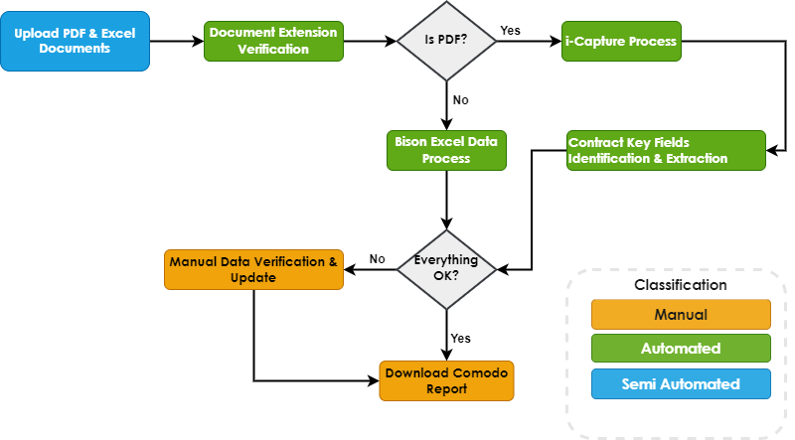

# Server Requirements

|  |  |  |
| --- | --- | --- |
| **SNO** | **ITEM** | **Recommended** |
| 1 | Processor | 4x3 GHz CPU (4Core 3GHz Speed) |
| 2 | RAM | 16GB to 32GB |
| 3 | HDD | 100 GB |
| 4 | Operating System | Windows 2016 R2 or above |

**Software:**

* Java 1.8
* Tomcat 8.x
* PostgreSQL 10
* Notepad++
* WinZip/7zip
* Python 3.7.4
* Node JS 12.16.3
* Chrome Browser

**Ports**

* **5434** or any other available ports
* **8080** or any other available ports
* **6006** or any other available ports

# Deployment Artifacts

* Apache-tomcat-8.5.76 Zip File consists of below files
  + BACE-Microservice War File
  + BACE-Web Application Zip File
* BACE Database Script File
* Icapture extraction packages

# Installation Steps

1. Install PostgreSQL Database and configure PG Tune suggested configurations

Open PGADMIN and Create BACE Database.

Database Name: BACE_POC

Go to PostgreSQL installed location and open bin folder in command prompt

Database Restore Command:

psql –h host_name–p port_number –d Database_Name –U user_name –f location and file name.backup

Run below command in cmd

psql –h 192.168.1.1 –p 5432 –d BACE_POC –U postgres –f D:\bacebddump.backup

1. Install java 1.8
2. Install Tomcat 8.x
3. Configure Heap Memory
4. Update BACE-Microservice war file properties

Open BACE-Microservice War file using Winrar or other apps and go to below location to update application properties

Location: BACE-Microservice\WEB-INF\classes

#Database properties

spring.datasource.url=jdbc:postgresql://localhost:5432/BACE_POC

spring.datasource.username=postgres

spring.datasource.password=gst

#Logging properties

logging.file=C:/BACE_POC/Logging/app.log

#BACE upload properties

bace.upload.root.dir= C:/BACE_POC/

source.dir=${bace.upload.root.dir}/Source/

archive.dir=${bace.upload.root.dir}/Archive/

output.dir=${bace.upload.root.dir}/Output Template/komodo-contracts.xlsm

#BACE Python OCR API

analytics.api=http://192.168.0.235:6006/runEngine?fileinput=

Update properties file with new database and file location properties

* Database Name
* Port
* Username
* Password
* Log file path
* File location base URL and sub folder

1. Change the BACE-Microservice url in BACE-WEB /main.js file

Need to change IP & Tomcat Port

var CommonConst = {

BASE_URL :'http://192.168.1.11:8181/BACE-Microservice/'

}

1. Install Python & Run Python Package
2. Access BACE Application with below credentials

<http://ip_address:port/>

Default Credentials:

Username: admin@amexgbt.com

Password:1234